Getting on to G suite!

G suite for education is a fabulous new resource that can assist us with learning both in school and at home. By using it children have the capacity to communicate with their teacher, open and complete assignments, and get direction in their learning even when not in school. This document should help your child log on with minimum fuss.

- Go to Google. This can be done in any browser, although it is designed for Chrome. On internet enabled devices such as smartphones and tablets, G suite apps can be downloaded for quick and easy sign in (Drive, Docs, Classroom, Slides etc have separate apps). There is a SIGN IN box on the top right.

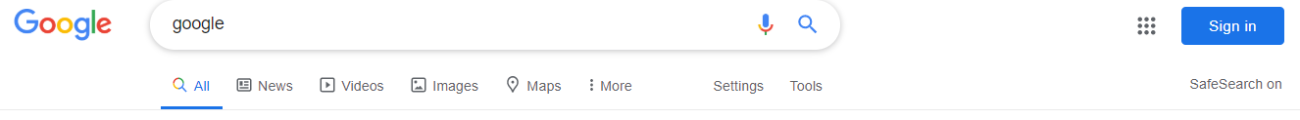
- Enter username and password. The user name will be your child’s first initial followed by their surname. This is then followed by @haywards.org.

    - For example: Joe Bloggs would log in using jbloggs@haywards.org

Children will be told their passwords.

(some children with double barrelled first names or surnames, or who have similar usernames to other children may have variations. Your child should know what their username is. Any problems please e-mail the school)
- Head to the waffle. You will notice a 3x3 square on the top right. We are calling this a waffle (because it kind of looks like a waffle). Click into it and head to account. You will see your child’s Google account welcome page. Go back to the waffle and you will now see the apps your child can access.

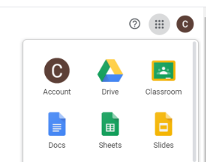

G Drive. Cloud Drive where all work is stored
First initial of account holder
Google Classroom
Account information
Google equivalent to Word, Excel & Powerpoint

Navigating Google Classroom.

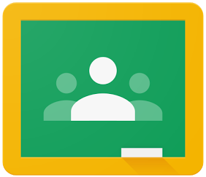

Google Classroom is the amazing portal that will allow your children to communicate with their classmates and teacher, find links to websites and pick up and complete assignments.
The children should have already joined their class in school, and be ready to rock and roll. If for some reason they haven’t joined, you will need to contact the class teacher to get the joining code. To do this, simply go to Classroom (if its the first time you’ll have to say you are a student) and on the top right there is a little addition sign. Click it, go to join class, and enter the class code.

Assignments will pop up on the stream when teachers set them, and instructions will be available and self-explanatory. IF you need any help, message the teacher!

Google Docs, Google Sheets and Google Slides

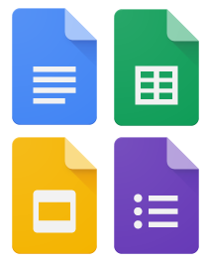

Like the teachers in school, most of you will be familiar with Microsoft Office. These offerings from Google are - in my opinion - a little easier to navigate and are designed to work seamlessly in the g suite package. There are slight differences, but nothing that can’t be solved with a quick play or a quick google.

