School Council Agenda
Meeting Date 11th February 2019
- Minutes of last meeting
Presented

- School Ambassadors
No children wanted to present their portfolios for School Council to deliberate and decide on.

- CHAT Teddy Bear Sleepover
How did it go? £143.20 raised.

- Supporting Charity letter from Sophia in Y2
Introduce Sophia and share letter. When do we want to do this? Summer term? (Already have charities for Spring, CHAT and DEBRA the Skin Charity)

- AOB

- Date of next meeting
Monday 25th February 2019.

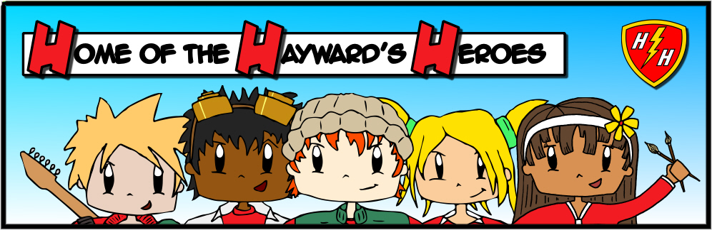
School Council Minutes
Meeting Date 11th February 2019
Attendance: All Class Representatives
- Minutes of last meeting
Approved.

- School Ambassadors
No children wanted to present their portfolios for School Council to deliberate and decide on.

- CHAT Teddy Bear Sleepover
How did it go? £143.20 raised and picture and report was in the Crediton Courier.

- Supporting Charity letter from Sophia in Y2
Sophia did a brilliant job of presenting her idea. The School Council unanimously agreed to do it. There will be a ‘wear what you like day’ and tombola. A message will go on the newsletter about this and the Secretary and Chair will write a letter about it.

- AOB
- There was a concern raised about balls being lost on the playground and if 1 class losses the other classes, is it fair that they no longer have a ball. It was agreed that classes within year groups should share. School Councillors will pass this message onto their classes.
- Another issue arose around putting equipment away as some was being found and played with before school starts. This should not happen and School Councillors will pass this message onto their classes.

- Date of next meeting
Monday 25th February 2019

